Journal: BMC Pulmonary Medicine

Title: Fluoroquinolone resistance and mutational profile of gyrA gene in pulmonary MDR tuberculosis patients
Authors: Saba Kabir¹, Zarfishan Tahir², Nadia Mukhtar³, Muhammad Sohail¹, Muhammad Saqalein⁴, Abdul Rehman¹*
Supplementary data (Figure)

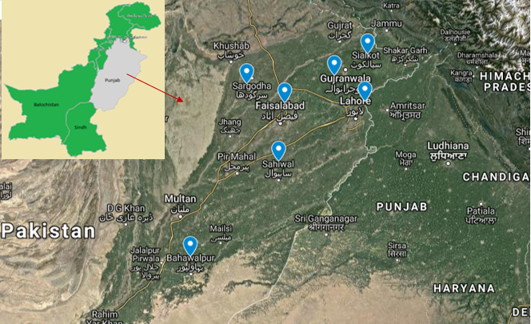
Figure S1: Samples were collected from Programmatic Management of Drug Resistant Tuberculosis (PMDT sites) of seven districts (Lahore, Faisalabad, Gujranwala, Sahiwal, Sargodha, Sialkot, and Bahawalpur) during May 2018 to March 2019.

